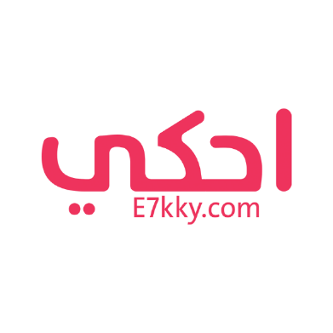
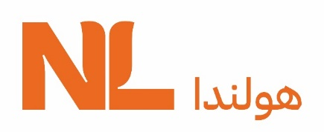

Joint Press Release
For Immediate Release

The Netherlands Embassy celebrates the success of 21 Egyptian women in collaboration with E7kky Magazine.
Netherlands Embassy, E7kky Magazine celebrate success of 21 Egyptian women

Cairo, 19 December 2021-
The Embassy of the Netherlands in Egypt in collaboration with E7kky Magazine launched on Wednesday the online campaign “21 of 21” to celebrate the success of 21 influential Egyptian women in 2021.
The campaign has been launched in conjunctions with the 16 days of activism to eliminate gender-based violence, which takes place each year between November 25 until December 10. The reason behind choosing this timing is to emphasise that ending violence against girls and women means more opportunities and successes.

“Ending violence against women will open the door to many Egyptian girls and women to succeed and develop their skills, which impact the whole Egyptian society.” Han-Maurits Schaapveld, Ambassador of the Netherlands to Egypt said.
The ambassador invited the audience to follow the campaign on the Embassy’s Facebook Page and on E7kky’s platforms on Facebook and Instagram.

Meanwhile, Namees Arnous, founder of E7kky Magazine and E7kky Network, described the process of selecting 21 women for the campaign as a tough one, explaining that, “because all of us believe that every woman has her own, unique story that worth telling.
“We all have many challenges that we try to overcome, but we are capable of being heroines in our own way.”

The “21 Influential Women of 2021” included Egyptian actress Demiana Nassar (Om Mario) following her participation in Feathers movie, the first Egyptian movie to win Cannes’ Critics’ Week Grand Prize. It also included Sue Ellen Hassouna, founder of Sue Ellen’s Foundation for Legal Development and the first female lawyer to join Administrative Control Authority; Youmna Dahroug, founder of Kafala in Egypt; and Malak Abd El shafi, first Egyptian and Arab woman to qualify for the swimming finals at Tokyo Paralympics 2020.
In addition, the list included Dr. Riham Awwad, co-founder of restore FGM the first specialized centre in restoring the complications of Female genital mutilation; Dina El Mofty founder of Injaz Egypt; Amira Shaaban, who got a full scholarship to study medicine after her study in one class schools (literacy); Radwa El Behiry, the Timpani player at the Mummies Parade; and Shaimaa El Naggar, founder of Adapt Garment for cloths for patients after surgeries.

Other names on the list were Sarah Gamal, the first international basketball referee; Fatma Selim, the youngest female parliament member; Shaimaa Tantawy, the founder of Man Ahyaha for community schools and education; Hadeer shalaby, Managing Director of Talabaat Egypt; Amira Youssef, Manager of Al-Ahly Academy for women football; Rahma Diaa, winner of Emerging Journalist 2021 from Covering Climate Now Organisation; and Heba Rahed, founder of Mersal Charity foundation.

Also, Dr. Gamila Nasr, the first woman president of the Scientific Council of the Egyptian Cardiology Fellowship; Heba Abd elgawad, Egyptologist and founder of Our Expatriate Monuments; Elham Fadaly, the first Egyptian to win the Physics Award of the year 2020 with the Eindhoven University; Nadia Gamal Eldin, founder of Rahet Baly Company to support Egyptian mothers; and last but not least the director Mariam Abu Ouf for her TV show “why Not”.

The Dutch Embassy and E7kky magazine expressed their pride of the Egyptian women and girls in the “21 of 21” campaign, and they emphasised that Egypt has many other influential and successful women in different fields. The list and the campaign are an attempt to shed light on a small part of those successes. They assure their desire to celebrate many other influential women in upcoming campaigns.

Press Contact:

For the Embassy of the Netherlands
Sally Barsoum, Policy Officer for Public Diplomacy: sally.barsoum@minbuza.nl
Website: https://www.netherlandsandyou.nl/your-country-and-the-netherlands/egypt
Facebook: http://facebook.com/nlembassyegypt

E7kky Magazine's Senior Content Writer/Team Leader: Nada Bedawy (Nada.bedawy@E7kky.com or Tel +20 1225530406)

